

SUBJECT | VULNERABILITY ANALYSIS
CODE | IKB21004 & IKB21403
TASK | FILE ANALYSIS – SCANNING RESULT

Question 1: Analyse packet1.pcap and find the flag.
Packet 37

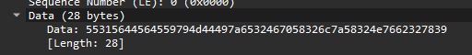
Found hex data string.

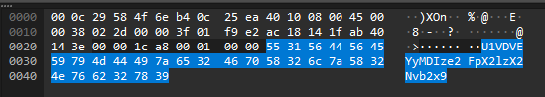
Highlighted hex and ASCII string.

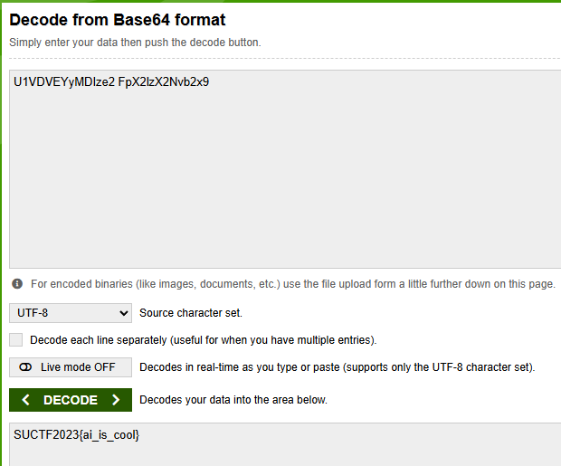
Translated ASCII to base64 format.
Flag = SUCTF2023{ai_is_cool}

Question 2: Analyse packet2.pcap and find the flag.
Reading ASCII string data of each packet.
packet 22 = Hello
packet 32 = How are you?
packet 70 = Are you a robot?
packet 329 = Did you ever play tic-tac-toe?
packet 409 = Yeah, of course.
packet 505 = But you don’t play anymore?
packet 535 = No
packet 587 = Why?
packet 651 = Because it’s a boring game. It’s always a tie.
packet 720 = Exactly. There’s no way to win.
packet 774 = The game itself is pointless.

Packet 156 - 235 describes an FTP login session.
Packet 205 = Mentions a txt filed named “Global_thermonuclear_war.gamerules.txt”
Packet 216 = Mentions a url that leads to a google doc


Decipher using tic-tac-toe code gets = EWMACHINAAVA

Question 3: Interpret an Nmap Output
PORT STATE SERVICE VERSION
21/tcp open ftp vsftpd 2.3.4 22/tcp open ssh OpenSSH 5.3p1 80/tcp open http Apache 2.2.8 139/tcp open netbios-ssn
445/tcp open microsoft-ds Windows 7 Professional 7601 Service Pack 1

Questions:
- What can an attacker do with each port?
Port 21 (FTP) = File Transfer Protocol (FTP) port is used for transmitting both commands, and data, including login credentials, in plain text. Attackers can use this to sniff, intercept, and many other attacks.
Port 22 (SSH) = Secure Shell (SSH) port is widely used for secure file transfers and server management tasks. An exposed port 22 allows automated botnets to perform brute-force attacks, credential guessing, and vulnerability exploits.
Port 80 (HTTP) = HyperText Transfer Protocol (HTTP) Port is used to transmit data in unencrypted plaintext. Attackers can use this to perform sniffing, session hijacking, and man-in-the-middle attacks.
Port 139/445 (SMB) = Server Message Block (SMB) protocol is for file and printer sharing in Windows networks. Access to this port allows the attacker to gain full administrative control over the system without needing any credentials
- What vulnerabilities are likely present based on the version?

Port | Service | Version | Known Vulnerability
21/tcp | vsftpd | 2.3.4 | Prone to backdoor vulnerability. An attacker can cause the application to open a backdoor on port 6200 by logging to the FTP server with the username ‘:)’
22/tcp | OpenSSH | 5.3p1 | Remote code execution, information leakage, and denial of service.
80/tcp | Apache | 2.2.8 | According to CVE-2008-2364, this version is vulnerable to denial of service.
445/tcp | Windows 7 Professional 7601 | Service Pack 1 | Known as “EtetnalBlue”. This vulnerability allows for remote code execution via the SMBv1 protocol, which can lead to complete system compromise.

- Which one is the highest risk and why?

- Based on the table above, the highest risk vulnerability would be port 445 (SMB) as it poses the highest impact exploit that provides the attacker to escalate their privileges to the system level instantly.

- What attack path can be built from this?

- Accessing backdoor through vsftpd 2.3.4 or MS17-010 EternalBlue to gain initial shell
- Create a new user
- Escalate privilege to administrative
- Extract user credentials
- Use other user credentials to move between system in the network

- What should be the remediation?

- Frequent OS updates whenever available to avoid being vulnerable to known vulnerabilities on older versions.
- Disable unnecessary port services that are not used.

Question 4: Identify the OS (OS Fingerprinting) - TTL

Image 1
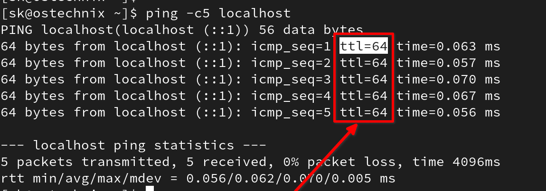
Answer: Linux
Image 2
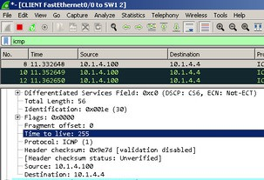

Answer: Solaris

Image 3:
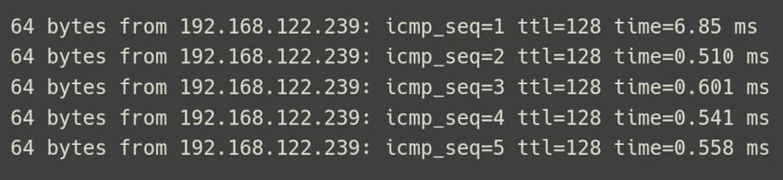

Answer: Windows

Question 5: Analyse the Nessus file
Upload to your nessus (Network_Scan.nessus) and analyse the files. Focus on critical or high findings that was identifies in analysis named “Ghostcat”.

- What is the affected Port number
- Port 8009
- What is the affected protocol
- Transmission Control Protocol (TCP)
- What is the CVSS Score of vulnerability found
- 9.8 (CRITICAL)
- Can you find any exploit related to this vulnerability?

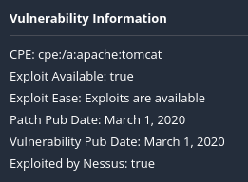

- Find CVE for this vulnerability.
- CVE-2020-1938 (Apache Software Foundation)
- CVE-2020-1745 (Red Hat, Inc.)

